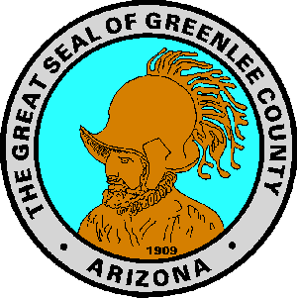
Official Candidates Updated: April 1, 2024
2024 Primary Election

Federal and State Candidates candidates can be found on the Secretary of State website at www.azsos.gov

BOARD OF SUPERVISORS

District 1
- Gomez, David (Democrat)
District 2
- No Official Candidates
District 3
- Wagley, Kara (Republican)

COUNTY ASSESSOR

- No Official Candidates

COUNTY ATTORNEY

- Griffith, Gary (Republican)

COUNTY RECORDER

- Miller, Erin (Republican)
- Stacey-Camacho, Sarah (Democrat)

COUNTY SCHOOL SUPERINTENDENT

- No Official Candidates

COUNTY SHERIFF
- Sumner, Tim (Republican)
- Solan, Dale (Republican)
- Medina, Daniel (Democrat)
COUNTY TREASURER
- No Official Candidates

